Elizabeth Langworthy Lord
109 Asteria Street
Greenville, SC 29617
Phone: (512) 808-7984
Friday, November 14, 2025
HAND DELIVERED
Thomas Phillips, J.D.
Chief Growth Officer
Contender Development, Inc., d/b/a Contender America
SC Entity ID 01156994
200 Smith Hines Road
Greenville, SC 29607
RE: Formal Notice of Claims for Age Discrimination, Hostile Work Environment, Retaliation, Constructive Discharge, and Other Claims Under Federal and State Law on behalf of Elizabeth Lord, Age 74
Dear Mr. Phillips:
As you are aware, I was hired as the Marketing Director of Blackstream Christie’s International and SVN Blackstream, Contender Development (CDI) companies, in July 2022. Corporate changes switched my employment to Contender Development, Blackstream International, and SVN Blackstream, and then in 2025 to Contender America, Blackstream International, and Nash Homes.
Attached, please find a timeline setting forth some of the specific events that are the subject of this letter. Also please find enclosed a preservation letter submitted through you to the addressees.
This correspondence serves as a detailed formal notification regarding the persistent and systemic adverse actions taken against me during my tenure as Director of Marketing for Blackstream Christie’s International Real Estate, SVN Blackstream, and Contender America (also known as Contender Development, Inc. (CDI)), culminating in my constructive discharge from my W-2 position. The facts establish multiple violations of the Age Discrimination in Employment Act (ADEA) and corresponding South Carolina employment laws.
As my current direct supervisor at Contender, I am providing you with this comprehensive overview of the claims, which include direct evidence of age-based discrimination, systematic marginalization, and subsequent retaliation following protected activity.

I. Analysis of Age Discrimination Claims (ADEA)
As an employee over the age of 40, I am a member of the class protected by the ADEA, which prohibits discrimination “because of such individual’s age.” To demonstrate unlawful discrimination, the evidence must show that age was the “but-for” cause of the adverse action. The pattern of conduct and explicit statements within CDI and Blackstream meet this burden.

A. Direct Evidence of Discriminatory Intent
The Supreme Court has recognized that courts give the greatest weight to age-related comments made by those with firing or promotion authority, classifying such comments as direct evidence when they bear directly on the contested employment decision.

1. Explicit Age-Based Statement by Senior Executive
During a meeting on April 25, 2025, attended by CEO Ford Elliott, HR Director Cameron Aldridge, and CFO/Attorney Peter Reinert, I expressed concern that the systematic undermining of my role was damaging my professional reputation. Mr. Reinert, a senior executive and part of the Contender Executive Committee, responded directly to my age, stating:
“At your age, why do you care about reputation?”
This explicit reference to my age as a reason to accept professional harm constitutes direct evidence of age-based discriminatory animus by senior leadership.

2. Age-Based Harassment and Hostile Work Environment
CDI maintained a work environment where I was subjected to age-based ridicule when Hayley Cape (age 28) publicly disclosed my age to co-workers in January 2025, causing me extreme embarrassment.
I also confronted and reported two younger colleagues, Adam Plous and Connor Parsons, who demeaned an older employee (age 68) by stating she was “too old to be working there and she should just quit.” After I defended her, I became a target of hostility and exclusion within the corporation.
My acute awareness of age bias was demonstrated when, after suffering a broken ankle and torn meniscus in a workplace fall on May 29, 2025, I returned to work after one day specifically to avoid any speculation that my age had caused the fall.

B. Disparate Treatment and Systematic Replacement by Younger Employees
My highly qualified position (28+ years of experience, technology certifications) was systematically dismantled, with my duties transferred to significantly younger, less experienced employees.

1. Transfer of Core Responsibilities
Core marketing responsibilities, including strategic initiatives and staff supervision, were taken from me and transferred to:
- Hayley Cape (age 28), Services and Experiences Coordinator
- Annette Wrenn, Operations Assistant
This included a complete company rebranding effort (Elliott Homes) planned in secret meetings between CEO Michael Mumma and Ms. Cape, while I, the Director of Marketing, was intentionally excluded. On April 25, 2025, I emailed Cameron Aldridge, HR Director a list of my concerns in response to a meeting with he, Ford Elliott, and Peter Reinert. I had previously addressed these concerns on numerous occasions with Blackstream’s Michael Mumma CEO and Christine Brodsky, COO.

2. Promotion of Younger Subordinate
Ms. Cape was elevated to the title “Senior Graphic Designer and Brand Manager”—functionally a marketing director position—while my own authority and responsibilities were stripped. Hayley Cape (formerly a staffing supervisor and hired as a Services and Experiences Coordinator) lists her position as Sr Graphic Designer and Brand Manager and Annette Wrenn (formerly an airline attendant and realtor) were progressively given my duties and responsibilities.
Annette was hired on Feb 14, 2025 as a Support and Operations Manager. On May 12, 2025 she lists her position on the website and in her signature block as Director of Operations. In the November 24, 2024 memo sent out by Michael Mumma, his organization chart has Hayley Cape reporting to me and her title is Services and Experiences Coordinator. Ms Wrenn has recently been released from employment due to a relationship with Mr. Michael Mumma. Ms. Cape also told me she, during her employment with Blackstream International, was in a relationship with Christine Brodsky’s son.
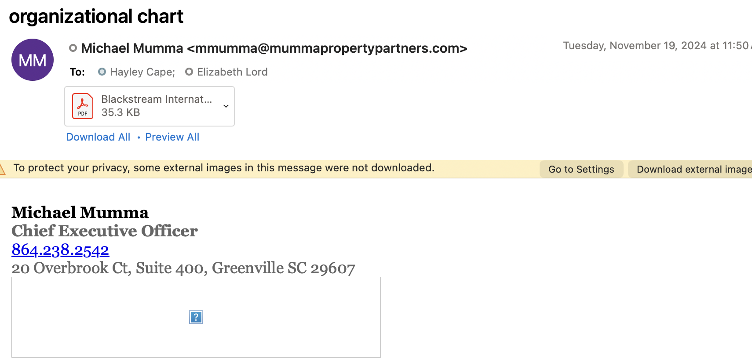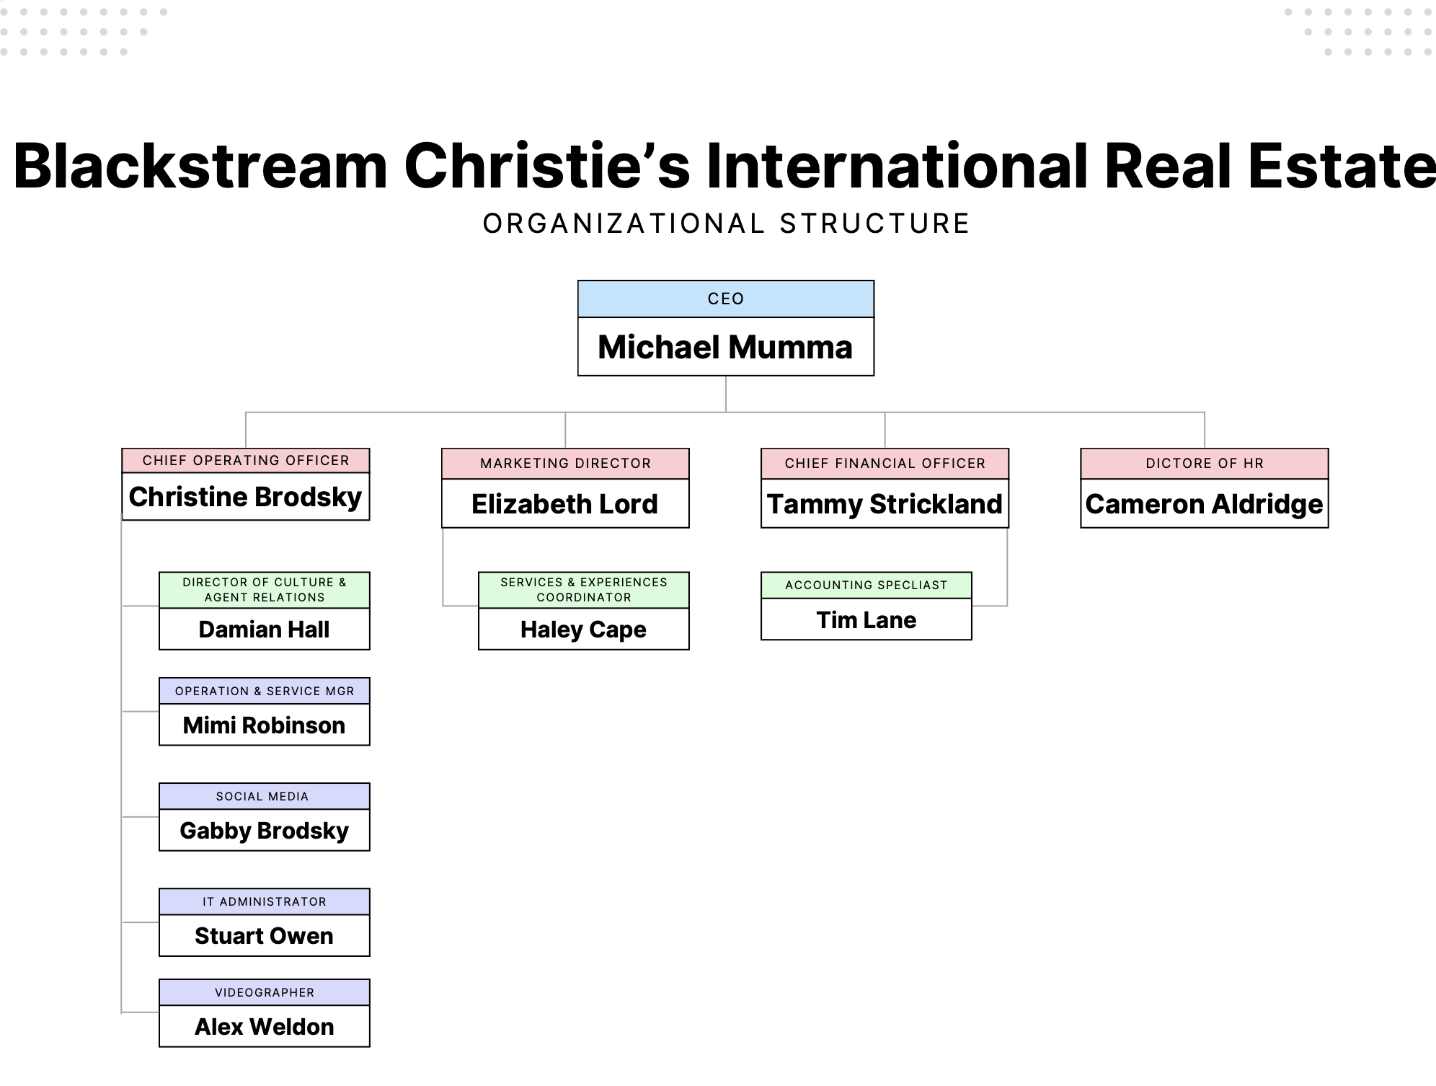

3. Reward for Insubordination
On March 17, 2025, Ms. Cape screamed “I don’t work for you” and walked out of a scheduled meeting. I reported this to HR that same day. HR was involved, but no discipline occurred.
Instead:
- March 19, 2025: My supervisory authority over Ms. Cape and Alex Weldon was completely revoked by Michael Mumma, CEO of Blackstream.
- Social media responsibilities were reassigned to Ms. Cape and Ms. Wrenn.

II. Other State and Federal Employment Claims
The documented conduct establishes additional claims for Constructive Discharge and Retaliation.

A. Constructive Discharge
A reasonable person in my position would have felt compelled to resign due to intolerable working conditions created by the employer.

1. Systematic Work Disregard
Between May and November 2025, I submitted numerous strategic initiatives, proposals, brand plans, budgets, and marketing materials to senior management. Of those submissions, almost all received no response.

2. Exclusion and Authority Removal
I was excluded from all strategic discussions with external agencies, including meetings with:
- Ghost Marketing / Britton Briley (October–November 2025)
And, I continue to be prohibited from making routine marketing decisions without CEO approval.

3. Physical Marginalization
After being removed from Blackstream:
- I was denied office space at 5 Century, told by Susan Roberts “there is no room.”
- Stuart Owen told me there was no room at 200 Smith Hines either.
- My former office was given to two agents without notice.
I was forced to sit in a cubicle I located myself in order to continue performing my job.

B. Retaliation

1. Stripping of Authority After Protected Activity
My full supervisory authority (confirmed by HR on March 13, 2025) was revoked two days after I reported Hayley Cape’s:
- Insubordination
- Firearm possession
- Concerning mental health comments (“I haven’t offed myself yet”)
to HR Director Cameron Aldridge on March 18, 2025.
The company’s handbook prohibits retaliation for reporting safety violations or prohibited conduct.

2. Post-Employment Evidence Spoliation
On September 2, 2025, after my constructive discharge:
- IT Administrator Stuart Owen informed me he was instructed by Christine Brodsky or Michael Mumma not to reset my password.
- I was locked out of my Blackstream email account.
- Mr. Owen stated he was “caught in the middle.”
This prevented me from accessing:
- My historical work materials
- Evidence supporting my claims
This constitutes retaliation and potential spoliation.

III. Proposal for Amicable Resolution
This is not an exhaustive discussion of the conduct and circumstances that evidence the basis of my legal claims, but it should be sufficient to allow Contender America to understand the gravity of the situation and come to an agreement regarding a severance package.
Without a severance package, I will continue to perform my duties in a cooperative manner with my customary positive attitude. And I expect remedial action taken to correct the damage that has been caused by the actions described in the letter. Given the extensive documentation—including direct age-related statements by senior leadership—CDI faces substantial exposure under the ADEA, which allows for:
- Back pay
- Front pay
- Liquidated (double) damages for willful violations
I wish to resolve this matter without litigation.
I seek:

1. Monetary Compensation
$300,000.00 - Equivalent to three years of salary as separation compensation.

2. Damages
$50,000.00 - For emotional distress and harm to my professional reputation.

3. Equitable Relief
Correction of personnel records and implementation of discrimination-prevention measures.
Absent such commitment, I will proceed with my EEOC charge and litigation.
Sincerely,
Elizabeth Langworthy Lord
Director of Marketing Development
Contender Development, Inc. (d/b/a Contender America)

TIMELINE — ELIZABETH LORD AGE DISCRIMINATION CASE

SELECTED SIGNIFICANT EVENTS

2022 — Employment Foundation
July 11, 2022 – Hire
- Hired as Director of Marketing for Blackstream Christie’s International Real Estate (BIRE) and SVN Blackstream.
- Reported to Lars Gruenfeld (COO, SVN) and Christine Brodsky (COO, BIRE) and worked with Michael Mumma (CEO).
- Initial salary: $100,000, split 50% Blackstream International / 50% SVN Blackstream.
- After budget adjustments:
  - 50% Contender, 25% BIRE, 25% SVN,
  - Then in 2025: 50% Contender, 25% Blackstream International, 25% Nash Homes.
- Held executive-level authority over marketing across all entities.

2022 – Early 2024 — Expansion then Fracture
- Built a multi-entity marketing department.
- Managed office launches, corporate branding, PR.
- Started masterclass series; launched monthly newsletter.
- Handled social media across all channels.
- Onboarded agents with personal branding guidance.
- Organized philanthropic initiatives.
- Wrote and published five editions of the bespoke real estate book, Guided Luxury at no cost to the company ($68,000 value).
- Managed major events, including a vendor village generating $38,000 in revenue.

2024 — Secrecy and Marginalization Emerge

Spring–Summer 2024 – Marginalization begins
- Lars bypassed Ms. Lord to assign work directly to Kell McCarty giving her projects and telling her not to tell Ms. Lord until after the fact.
- Christine Brodsky had hired Hayley Cape as Services and Experiences Coordinator.
- Hayley began doing graphic design work for other executives (e.g., Mumma, Damian Hall), causing increasing resistance to working with Ms. Lord. In addition, Michael Mumma was paying Hayley personally to work on his personal business ahead of agents.
- On several occasions, Christine Brodsky asked Ms. Lord to see why Hayley was so “swamped” and could not get to agent work. Much of the work she was doing was for Biltmore Walk, a project of Tom Marchant. When Ms. Lord tried to assist with some of the projects in “ClickUp” she was told, “I’ll let you know if I need help.”. This is also true of the reaction Julia-Reagan Clark received when Ms. Lord asked her to assist Hayley on projects.
- Kell quit after not receiving a promised raise; reported undocumented promises by management. When Ms. Lord asked Lars Gruenefeld why he had bypassed HR and her during this incident (and told Kell not to tell Ms. Lord that she was negotiating for more money or would leave) – Lars told Ms. Lord that it was Michael Mumma who decided to withhold all information from Kell’s director supervisor, Ms. Lord.
- Prior to this (and not having this information) Ms. Lord referred Kell to CEO Mumma to intercede. Kell quit.
- Prior to the sale of SVN Blackstream, Angie Looney was hired as Marketing Director for Reedy River Retail with a portion of her salary paid by SVN Blackstream. This was extremely disturbing to both Ms. Lord and her assistant, Julia-Reagan Clark. SVN sold (Q1 2025, SVN Palmetto transition).

Fall | Winer 2024 – Information Gatekeeping
- CEO Mumma and 28-year-old Hayley Cape held secret “Elliott Homes” rebranding meetings, excluding the Marketing Director.
- Hayley later admitted she had lied about the project when asked directly by Ms. Lord.
- Rumors grew regarding inappropriate relationships and favoritism toward younger female staff.

2025 — Escalation and Constructive Discharge

January 2025
- Jan 8: “All Hands” email listed Ms. Lord as Contender senior staff → evidence of joint control.
- Hayley publicly disclosed Ms. Lord’s age → ridicule ensued.
- Younger employees Plous & Parsons mocked an older worker (68).
- Ms. Lord defended the worker → felt humiliated.

February 2025
- Feb 12: Michael Mumma, Blackstream CEO instructed Christine Brodsky to hire Annette Wrenn as her operations assistant.
- Feb 14: Annette Wrenn starts as Support and Operations Manager.
- Mid-Feb: Broadstreet “line-drawing”—Mumma ordered brand separation.
- Ms. Lord proposed dual-role CMO plan (½-time Contender + 1099 BIRE).
- Ford Elliott later dismissed it as a “money grab” (Ex. C/G).
- Payroll rumors spread (concerns companies would not meet payroll after April).
- Rumors intensified about Mumma–Wrenn relationship; confirmed later by HR.

March 2025
Mar 5 – Christie’s Conference:
- Ms. Lord witnessed inappropriate behavior between Mumma and Wrenn.
- Cameron Aldridge later confirmed he monitored the situation while at Blackstream’s Overbrook office and the rumors were true.
- Alex Weldon reported Mumma denied the affair when questioned by Ford in January.
- Haley moved almost all of the projects in “ClickUp” into her name.
- Wrenn ultimately received over one year of severance pay when terminated.
- Agent Katrina Campbell also observed problematic behavior at a conference and reported this by phone to Ford Elliott.
Mar 14–16 – Noncompliance:
- Hayley repeatedly no-showed meetings.
Mar 17 – Screaming Insubordination:
- Hayley screamed: “I don’t work for you!”
- HR spoke to her; no discipline issued.
Mar 18 – Firearm Report:
- Ms. Lord notified Cameron Aldridge, HR Director that Hayley had a firearm.
- HR texted that Mumma “would talk to her”; no meeting occurred. Cameron texted Lord about this and also repeated this to her when she told him she was still concerned for her safety (in person).
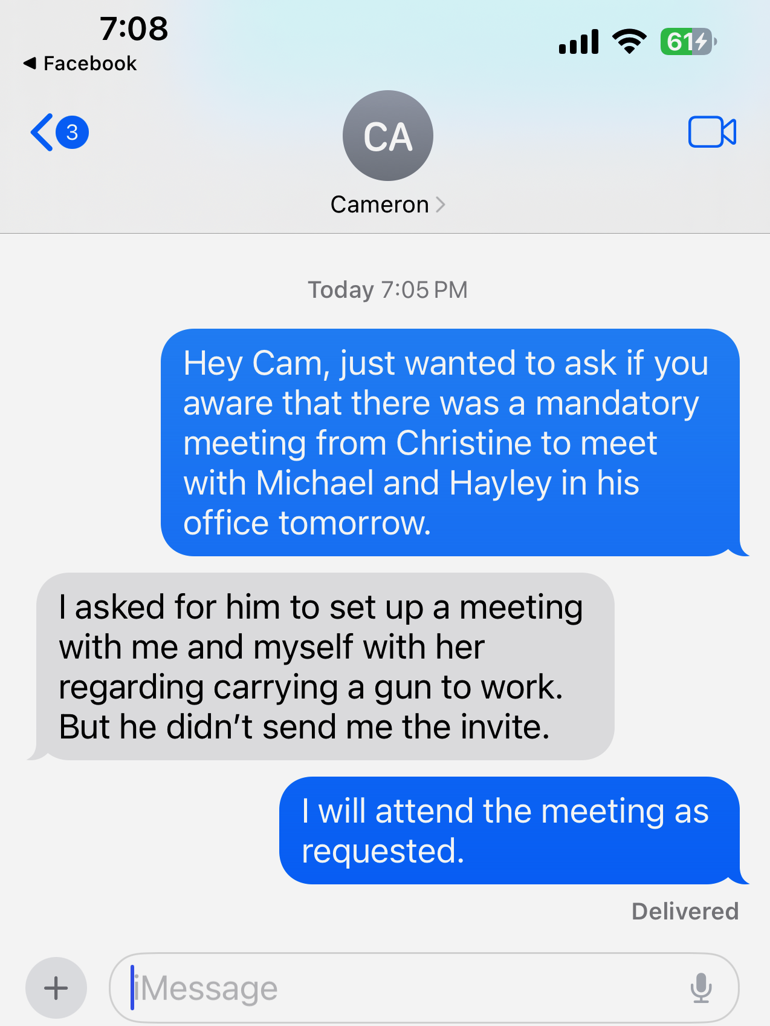
Mar 19 – Authority Revoked:
- In a meeting excluding HR, Blackstream CEO Mumma stripped Ms. Lord of all supervisory authority (humiliating her in front of Christine Brodsky and Haley Cape):
  - Hayley and Alex would no longer report to her.
  - Social media reassigned to Hayley & Annette.
Late March – Reward for Misconduct:
- Hayley received a discounted Overbrook apartment, despite firearm possession and insubordination (Ex. H).

April 2025
- April 16, 2025: HR Directive: Aldridge reaffirmed Ms. Lord’s authority over Hayley & Alex and budget control in email
- Apr 14–18: Ms. Lord was excluded from:
  - Nash Homes website decisions,
  - Office reassignment (“new office containing Lord’s personal items has other agents name written on glass window with no notification or explanation as to why she was denied the office she had chosen with Christine Brodsky.
  - Lake Keowee launch.
- Apr 21: Scheduled safety meeting canceled
- Apr 25: HR memo issued
- CFO Reinert made discriminatory remark:
“At your age, why do you care about reputation?”
- Ms. Lord was moved to Contender full-time—title preserved, authority eliminated.

May 2025
- May 1: Transition to Contender — constructive demotion as she was no longer the Marketing Director for Blackstream Christie’s International, Nash Homes, Blackstream Real Estate Academy, Blackstream Commercial Real Estate
- May 5: Denied office space at 5 Century.
- May 9: Meeting with Thomas Phillips — told “there is a budget,” but none was ever provided.
- May 29 – Workplace Injury:
  - Fell down stairs; broken ankle + torn meniscus that will require surgery.
  - Filed worker’s comp on site.
  - Returned after 1 day to avoid age-based speculation.

June – August 2025
- Contender CEO meetings canceled on June 4, 9, 12, and July 31.
- Continued website-access issues with Susan Roberts.
- Aug 1: Team-building and Holiday Gala moved from Marketing → HR. Even Maxine Turner and Jennifer Liddy questioned this knowing that Lord had managed all previous events.
- Aug 7: Ford directed that the Contender website mirror a Florida agency — no resources provided.
- Aug 18: Susan Roberts outburst: “I just want to work with Hayley.” (Lord outside Phillips office)
- Aug 28: Budget data refused. Website access refused.

September 2025
- Sept 2 – Email Lockout:
  - IT (Stuart Owen) stated Brodsky and/or Mumma instructed him not to reset Ms. Lord’s password.
  - Ms. Lord lost access to key BIRE communications
  - Owen stated he was “caught in the middle.”
- Sept 23 – Performance Praise:
  - Connor Parsons praised her proposal (“No, this is fantastic!”)
  - Undercuts any pretext that performance was the issue.

October – November 2025
- Oct 31: Ghost Marketing meetings held without Ms. Lord.
- Nov 11: EEOC Complaint filed.
- Nov 12: Final documentation and timeline assembled.
- (Events after Nov. 12 omitted at Ms. Lord’s request.)

SUPPORTING PATTERNS (2022–2025)
- Repeated meeting cancellations (≥ 4).
- Removal of budget authority and decision-making rights.
- Transfer of duties to significantly younger employees (Hayley age 28; Annette approx. 30).
- Retaliation following HR complaints.
- Ignored firearm safety report resulting in reward, not discipline.
- Systematic exclusion and communication blocks.
- Direct age-based remark (“At your age…”).
- Pattern of sexual favoritism creating a gender- and age-biased culture.

Elizabeth Langworthy Lord
109 Asteria Street
Greenville, SC 29617
Phone: (512) 808-7984
Friday, November 14, 2025
To:
Ford Elliott, CEO
Thomas Phillips, Chief Growth Officer
Michael Mumma, CEO, Blackstream Christie’s International Real Estate
Christine Brodsky, COO, Blackstream Christie’s International Real Estate
Peter Reinert, CFO
Cameron Aldridge, Director of Human Resources
Corporate Address (for all Contender-related entities):
200 Smith Hines Road
Greenville, SC 29607
Re: Formal Preservation of Evidence Relating to My Employment, Discrimination, Retaliation, Hostile Work Environment, Safety Concerns, and Related Claims

I. COVERED CONTENDER ENTITIES (FULL LEGAL NAMES AND SC ENTITY IDS)
This preservation demand applies to the following Contender-affiliated entities, each of which has had involvement in, or benefited from, my work and employment:
1. Contender Development, Inc. d/b/a Contender America
South Carolina Entity ID: 01156994
Corporate Headquarters: 200 Smith Hines Road, Greenville, SC 29607
This preservation requirement also applies to:
- Blackstream Christie’s International Real Estate
- SVN Blackstream
- Nash Homes, LLC
- Blackstream Real Estate Academy
- Blackstream Property Management
- Streams Development
- Mumma Property Partners (where company staff performed work using corporate resources)
- Contender America, LLC, South Carolina Entity ID: 01466962
- Contender America Properties, LLC, South Carolina Entity ID: 01467035
- Broadstreet Global / Broad Street Global Management (as to all communications and materials referencing me, including those relating to investor oversight and the SEC investigation)

II. PURPOSE OF THIS LETTER
I am directing all Contender-related entities, all Blackstream/SVN divisions, and all affiliated business units to immediately preserve all materials relating to:
- My employment
- My reporting structure
- My work assignments
- My performance
- Workplace safety concerns I reported
- Any internal or external discussions about me
- Any potential legal claims involving me
This includes (but is not limited to) evidence relating to:
- Age discrimination
- Sex discrimination
- Retaliation
- Harassment
- Hostile work environment
- Constructive discharge
- Safety violations (including the firearm incident documented in my November 14, 2025 letter)
- PR or communications management involving Broadstreet Global
- Any statements made about me to third parties
- Any internal discussions about possible, anticipated, or potential legal claims involving me
This preservation obligation extends to every location where relevant data may reside, including company servers, employee devices (personal or company-issued), cloud platforms, social media accounts, shared drives, and messaging systems.

III. BROADSTREET GLOBAL MATERIALS — CRITICAL CATEGORY
You must preserve all materials involving Broadstreet Global / Broad Street Global Management, including:
- My direct communications with Mr. Ryan Feingold
- Any communications to or from any Broadstreet officer, analyst, consultant, or representative referencing me
- Any internal discussions about Broadstreet that mention me
- Any documents or discussions related to “drawing a line between the companies” following Broadstreet’s SEC-related exposure
- Any PR or crisis-response drafts I prepared or discussed with leadership
- Any meeting notes, handwritten notes, or summaries reflecting any discussion involving my name and Broadstreet
This includes every meeting in which my name was raised in connection with Broadstreet’s questions, concerns, requests, directives, or risk assessments.

IV. PRESERVATION OF ALL STATEMENTS MADE TO THIRD PARTIES ABOUT ME
You must preserve every statement made about me to any third party, including but not limited to:
- Real estate agents
- Vendors
- Independent contractors
- Consultants
- Investors
- Partner companies
- Ghost Marketing / Britton Briley
- Any person affiliated with Broadstreet Global
- Anyone inquiring about my employment status
- Anyone who received explanations, rationalizations, or statements about changes to my role
This includes statements relating to:
- My age
- My performance
- My ability to perform my duties
- Reasons for removing my authority
- Changes to my reporting structure
- Any suggestion I was transitioning to 1099 status
- Any claim I was “involved in controversy”
- Any reference to “issues” with me
- Descriptions of the March 17, 2025 incident
- My safety reports, including the firearm incident
- Any suggestion I was “too old,” “not needed,” “overreacting,” or “a problem”
- Any reference to potential discrimination or legal claims
You must preserve all written, digital, spoken (if memorialized), or recorded forms of such statements.

V. PRESERVATION OF ALL INTERNAL DOCUMENTS RELATING TO POTENTIAL CLAIMS
You must preserve all documents, drafts, notes, emails, chats, text messages, and summaries relating to allegations, complaints, discussions, or evidence of:
- Age discrimination
- Sex discrimination or harassment
- Harassment or bullying
- Hostile work environment
- Retaliation
- Workplace safety concerns (including the firearm incident)
- Worker’s compensation claim from the May 29, 2025 fall
- Any investigation (formal or informal) involving me
- Any discussions about removing me from positions, changing my reporting structure, or reducing my authority
- Any reference to concerns I raised with HR or leadership
- Any discussion of the “optics” of moving me to Contender America
- Any discussion about my ability to perform given my age
- Any comments, discussions, or analysis of possible, threatened, or anticipated legal claims
This includes:
- HR summaries
- Notes taken by Cameron Aldridge
- Emails, Teams messages, and text messages
- WhatsApp or private message channels
- Notes taken during or after meetings
- Talking points or drafted statements
- Communications between executives regarding my role or status
- Any documentation referenced in this letter or in my November 14, 2025 letter to Thomas Phillips or in the attached timeline
Nothing whatsoever on these subjects may be deleted, altered, overwritten, or concealed.

VI. INDIVIDUALS WHOSE DATA MUST BE PRESERVED
You must preserve all data created, stored, sent, received, or deleted by the individuals below, including device backups and metadata.
- Ford Elliott
- Thomas Phillips
- Michael Mumma
- Christine Brodsky
- Peter Reinert
- Cameron Aldridge
- Hayley Cape
- Annette Wrenn
- Alex Weldon
- Julia-Reagan Clark
- Lars Gruenfeld
- Tammy Strickland
- Rachel Parrott
- Katrina Campbell
- Lissa Lipsey
- Susan Roberts
- Josh Howard
- Adam Plous
- Connor Parsons
- Stuart Owen
- Any other IT administrators with access to my accounts
- Any employee who communicated with Broadstreet Global
- Any person who participated in, contributed to, or documented meetings in which I was discussed

VII. NO DELETION, MODIFICATION, OR ALTERATION OF ANY MATERIAL
Effective immediately, you must suspend all deletion, purging, or modification of any relevant information.
This includes:
- Outlook or Exchange email deletion rules
- Microsoft Teams retention limits
- Text message/iMessage/WhatsApp deletion
- ClickUp archival rules
- Website version overwrites (WIX, CRM, WordPress, or other platforms)
- Cloud storage deletion
- Shredding of physical files
- Reassignment of document permissions or ownership
- Laptop or device replacement
- File cleanup on any platforms (including CRM, WIX, or internal systems)
- Deletion of screenshots, drafts, notes, or backups
All data must be preserved in original form, with metadata intact.

VIII. CONFIRMATION REQUIRED
Please provide written confirmation within five (5) business days that:
- A complete preservation hold has been implemented.
- All custodians have been instructed not to delete or modify any data.
- All auto-delete and purge functions have been suspended.
- All covered entities and LLCs have been notified.
- IT has implemented the required technical preservation measures.

Sincerely,
Elizabeth Langworthy Lord
Director of Marketing Development
Contender Development, Inc. (d/b/a Contender America)

